1. Which side app would you like to use?
2. Android mobile app



1. Web app

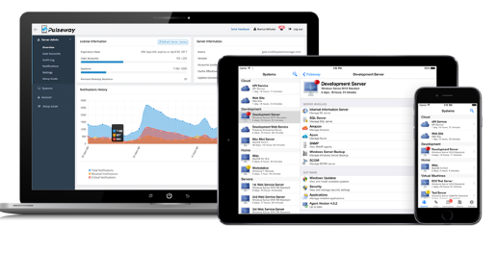

1. Hybrid app



1. What would you like to do when error occur in the app?

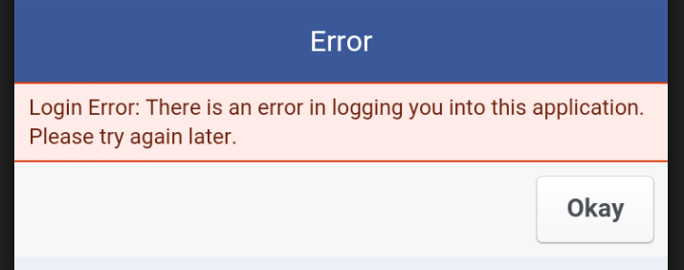

|  |  |  |  |  |
| --- | --- | --- | --- | --- |
| Version | Date | Add/modify/delete | Editor | description |
|  |  |  |  |  |

Tester will to find where the failure occur and use the form to record.